Ungaretti, Giuseppe (1888-1970)
Elena Fabietti, Johns Hopkins University

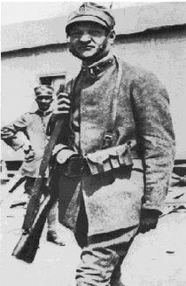
(Ungaretti during World War One: http://en.wikipedia.org/wiki/Giuseppe_Ungaretti)

Giuseppe Ungaretti was a major Italian author of the first half of the twentieth century. In his poetry he achieves a massive reinvention of Italian poetic language, abolishing punctuation, dismembering syntax, fragmenting the verse into single verbal units. Words acquire a completely new relevance and density, which counterweigh the abundance of silence and blank space, in ways that resonate with the models of Symbolism and the avant-garde, without coinciding with these.

Education and war years
Born in Alexandria in Egypt in 1888 as the son of an emigrant family, Ungaretti received a bilingual education in Italian and French. After moving to Paris in 1912, he became part of Parisian intellectual and poetic life, attended classes at the Sorbonne, and came into contact with all major cultural personalities of the time, such as Henri Bergson, Guillaume Apollinaire, Pablo Picasso, and the Italian futurists, among others.

Ungaretti moved to Milan in 1914 and, with Italy’s entry into World War One, volunteered as a soldier in the northern Italian region of Carso from 1915 to 1916. This experience intensely affected his poetic production, and was conveyed in his first book of poems, Il Porto Sepolto (The Buried Harbor), published in 1916. The title’s image of the buried harbor refers to a hidden inner dimension to be explored by the poet, while the central theme of the book is the experience of the war, during which Ungaretti was exposed to the brutal death of fellow soldiers in the trenches. The aridity of the landscape is paired with the contemplation of death and the fragility of the human condition, as depicted in the poem Fratelli. At the same time, the book is marked by a cosmic attachment to life, itself triggered by the experience of death and transience, as in the poem “Veglia” (“Vigil”) or “I fiumi” (“The rivers”). After a characteristic ongoing work of revisions and textual changes, The Buried Harbour was later incorporated in subsequent collections, culminating in the book L’allegria (Joy), published in 1931. The latter title is paradoxical for a work that focuses on the experience of war and human frailty, as in the poem “Soldati” (“Soldiers”), and yet suggestive of the deep vitalist drives of Ungaretti’s poetics. From the formal point of view, this comprehensive work displays an absolute concentration of the poetic word, both in its semantic density, aimed at evoking absolute meanings, and in the fragmentary brevity of its elocution, which is devoid of punctuation (exemplarily, the poem “Mattina” [“Morning”] consists only of two short verses).

The post-war years
After the war, Ungaretti settled in Paris, where he worked as a correspondent for the newspaper “Il Popolo d’Italia” and collaborated with French literary journals, while also publishing his poetry in Italy. After marrying Jeanne Dupoix in 1920, he moved to Rome the following year, working in a modest position for the Government’s Foreign Affairs Office. The 1920s saw him join the fascist movement and later convert to Catholicism. At the same time, Ungaretti’s poetry embraced more classicist patterns, though reshaped by a baroque inspiration, largely derived from the wide exposure to baroque art in Rome. This new aesthetic measure is displayed in the book of poems Sentimento del tempo (A Sense of Time), written between 1919 and 1933, which marks Ungaretti’s second poetic season. An emphasis on memory and tradition is the organizing principle of the book, both formally and thematically: returning to traditional metric patterns and a more distended syntax, the book focuses on the heritage of the past, often displayed in mythological narrations. The resulting tone is more articulated, more difficult and less direct than the first collection, and as such was considered the point of reference for the poetic movement known in Italy as ermetismo (suggesting the “hermetic” character of that poetry).

In addition to his poetic work, Ungaretti was a correspondent for the newspaper Gazzetta del Popolo in the first half of the thirties, for which he wrote several travel reportages, later collected in the book Il deserto e dopo (1961). His first book of poetic translations, of William Blake, Luis de Góngora, and Stéphane Mallarmé among others, also appeared in 1936. Ungaretti translated extensively in the years to come, notably Shakespeare and Racine.

The years in Brazil
From 1936 to 1942 Ungaretti lived in Brazil, teaching Italian Literature in São Paolo. Tragic events in the poet’s life, namely the death of his brother and of his young son Antonietto, in addition to the onset of the Second World War, lead to the writing of the book of poems that marks his third poetic season, Il dolore (Affliction), completed between 1937 and 1946. The devastating experience of the loss of his child is told through the direct voice of the first person (as in the fragmentary journal of “Giorno per giorno” [“Day by day”]), which conveys a vast, tragic sense of life and despair. Also the experience of WWII enters the book, with poems written in the days of Rome’s occupation in 1944.

The years of public success
After his return to Italy in 1942, Ungaretti acquired further fame and became extremely active as a public intellectual, well past his retirement as a Professor of Italian Literature at the University of Rome in 1958. In his long-time project La terra promessa (The Promised Land), thematically inspired by Virgil’s Aeneid, which he had started in the thirties and published, in a fragmentary form, in 1950, Ungaretti dwells on the impossibility of reaching the promised land, an enterprise doomed to fail under the spell of death as a cosmic condition. These tragic accents receive a more autobiographical inflection in the later collection Un grido e paesaggi (A shout and Landscapes), from1952. In 1960 the collection Il taccuino del Vecchio (The Old Man’s Notebook) reiterates the autobiographical exploration of time as a central theme of Ungaretti’s poetics, from the special vantage point of the poet as an old man.

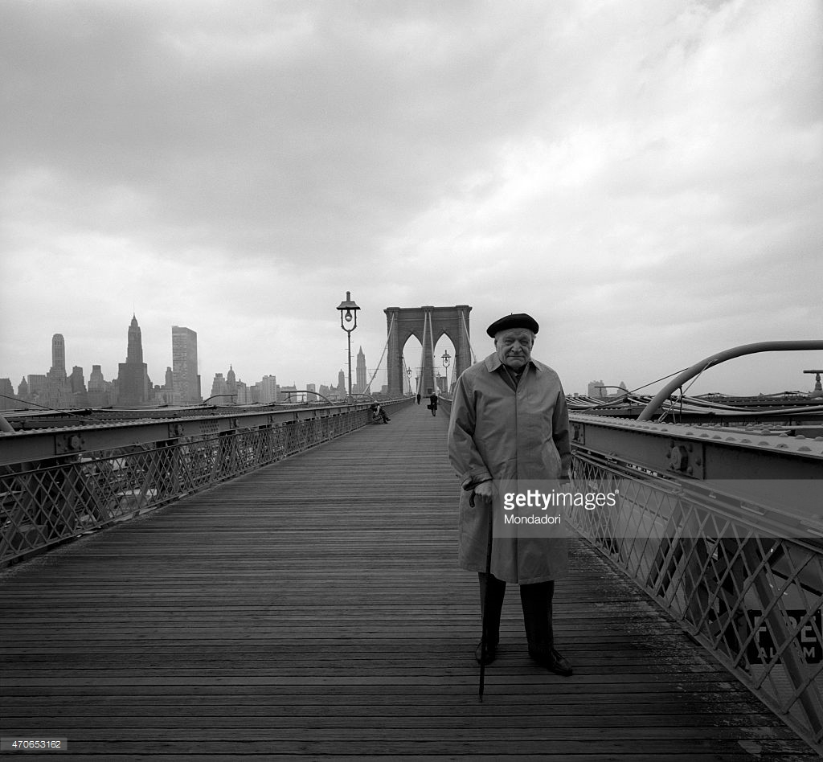
(Ungaretti in New York, 1964: http://www.gettyimages.com/detail/news-photo/the-great-italian-poet-giuseppe-ungaretti-stands-still-on-news-photo/470653162)

The last years
In the last decade of his life, Ungaretti was extremely active as a cultural figure, both in Italy and abroad. His poetry returned to a more sober cadence with the publication of Proverbi (1969) and the love poems of Dialogo (1969).

In the 1960s, he lectured widely in Italy and abroad, connecting with many of the most relevant artistic personalities around the world, from Allen Ginsberg, whom he met in New York in 1964, to the singer Vinicius de Moraes, whom he met in Rome a few years later. For his eightieth birthday he received extensive official recognition. In 1969, a complete edition of his poetry, containing his own notes and comments, was published under the title Vita d’un uomo (Life of a man), later enlarged to encompass all of his writings. In 1970, on returning from a trip to New York, Ungaretti died in Milan.

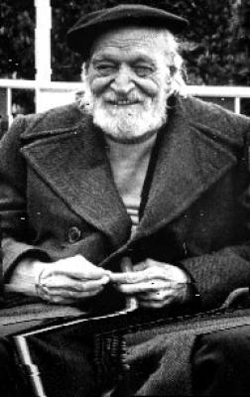
(http://www.athenamillennium.it/letteratura/Giuseppe_Ungaretti.html)

References and further reading

Collections

Ungaretti, G. (1969), Vita d’un uomo: Tutte le poesie. Milano: Mondadori.
Ungaretti, G. (1974), Vita d’un uomo: Saggi e interventi. Milano: Mondadori.
Ungaretti, G. (2000), Vita d’un uomo: Viaggi e lezioni. Milano: Mondadori.

Translations

Ungaretti, G. (1971), Selected poems. Edited and translated, with an introduction and notes, by Patrick Creagh. Harmondsworth: Penguin.
Ungaretti, G. (2003), Selected poems. Translated, annotated, and with an introduction by Andrew Frisardi. Manchester: Carcanet.

Further readings

Cambon, G. (1967), Giuseppe Ungaretti. New York: New York University Press.
Mengaldo, P.V. (1978), “Giuseppe Ungaretti”, in Poeti italiani del Novecento. Milano: Mondadori.
Ossola, C. (1982), Giuseppe Ungaretti. Milano: Mursia.
Piccioni, L. (1970), Vita d’un poeta. Giuseppe Ungaretti. Milano:

External links

Ungaretti reads his poem Sono una creatura and speaks of his poetic influences
http://www.rai.tv/dl/RaiTV/programmi/media/ContentItem-e0f7d766-08e8-4933-aeb3-6ff47fee460a.html

Ungaretti reads his poem I fiumi
http://www.rai.tv/dl/RaiTV/programmi/media/ContentItem-5ea17145-cd15-4511-82c6-b223e127910e.html

For more links to videos with Ungaretti:
http://www.rai.tv/dl/RaiTV/ricerca.html?q=ungaretti&sort=date:D:L:d1&filter=0&getfields=*&site=raitv&start=10

Pier Paolo Pasolini interviews Ungaretti in Comizi d’amore (1965)
https://www.youtube.com/watch?v=LKr85prCmPY

